|  |
| --- |
| Grounded |
| 3D Escape Game Document |
| Version 1.1 All work Copyright © 2015 by Cistronix Games. All rights reserved. Jason Huang (300818592) Nov.20th,2015 |
|  |



Table of Contents

Version History 2

Game Document 2

Game Overview 2

Game Play Mechanics 2

Camera 2

Controls 3

Interface Sketch 3

Start Screen 3

Player can pick up Items 3

Hazards in Game 3

Some Paths are Blocked 3

Level Sketch Ver. 1 3

Level Sketch Ver. 2 3

Game World 3

Levels 3

Game Progression 3

Characters 3

Enemies 3

Weapons 3

Items 4

Script 4

Scoring 4

Sound Index 4

Story Index 4

Art / Multimedia Index 4

Design Notes 5

Future Features 5

# Version History

Project Github Link: <https://github.com/Strifez/Grounded>

# Game Document

## Game Overview

The goal of the game is to escape the subway by jumping over hazards such as fire and collect supplies such as canned food and supplies to reach the end of the level.

## Game Play Mechanics

The mechanics of the game a fairly simple, mostly jumping on walls of fire and patches of fire. Player is can run and jump but takes damage when they touch hazards. There are no enemies currently in the game.

## Camera

This is a 3D escape game and the camera is a child of the player (parent). Therefore, the camera is focused on the player. The player can move forward, backwards, left and right to explore the level and so does the camera. The Projection of the camera is Orthographic.

## Controls

The player movements are the standard arrow keys (Up, Down, Left, And Right) and the Space key is for the jump. The shift key is for sprinting. The mouse is to rotate the camera and where the mouse is pointing that is where the player will move.

## 

## Interface Sketch

## Start Screen

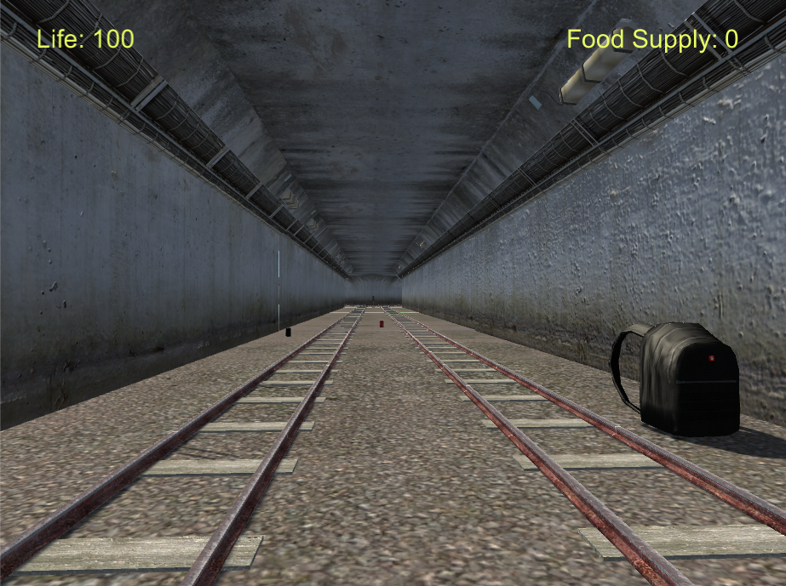

## Player can pick up Items

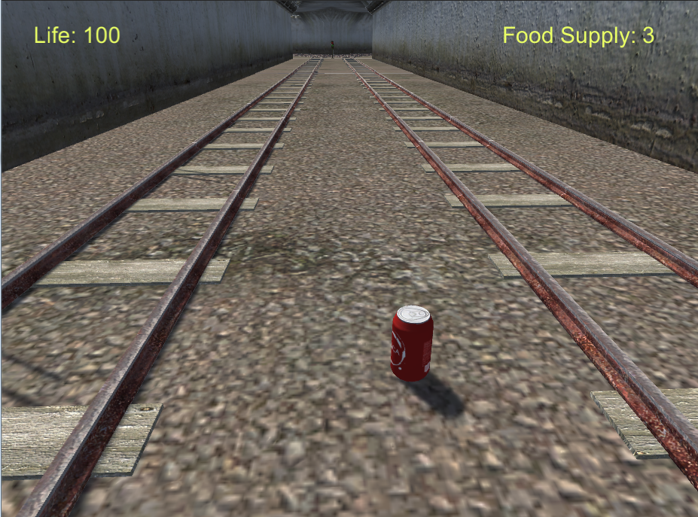

## 

## Hazards in Game

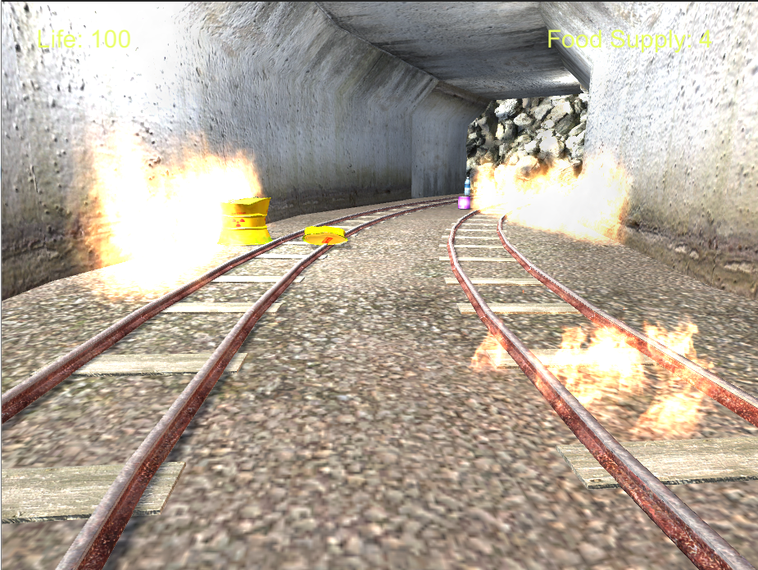

## 

## Level Sketch Ver. 1

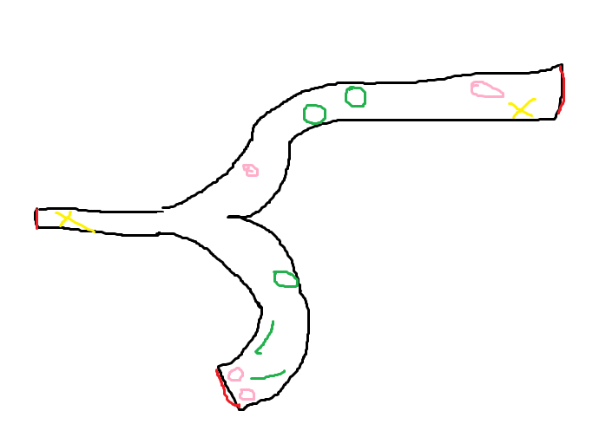

The red lines are means that the areas are blocked, yellow x’s means the start and end areas, the green is marked as where the obstacles will be and the pink are pick-ups.

## Level Sketch Ver. 2

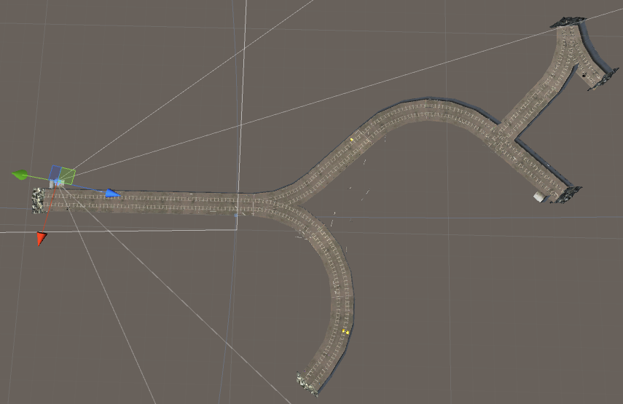

This is in Unity, 3D top view of the entire level 1.

## Game World

The setting is underground subway tunnel; Josh is trapped and needs to find a way out. Josh finds supplies and food nearby at when he wakes up, seems like someone has placed him there for a reason.

## Levels

There is only one level currently; more levels will be implemented in the future versions. The first level is fairly simple and there are no enemies, just obstacles that the player has to avoid. The goal is to collect supplies and avoid the hazards to escape the tunnel.

## Game Progression

The game progression is linear currently but when more levels which includes an enemy, it will make the game a bit more exciting. There are no Start menu or Game Over screen so far.

## Characters

Josh is the main character of the game, because it is a first person the player will not see themselves.

## Enemies

No enemies just hazards, such as patches of fire, and walls of fire.

## Weapons

Josh is unarmed; later on in the levels he will find a weapon to defend himself against the unknown enemy.

## Items

Items include backpack (supplies), water bottle, canned food and soda. All are essential to Josh escape and survival in the tunnels. More items are to be added at later levels.

## Script

**PlayerController** (asset store)

3 scripts inside the PlayerController script which are the HeadBob, MouseLook and RigibodyFirstPerson script. The PlayerController is a script for moving the player, the HeadBob is for when the player moves the screen bobs to make it look like the player is walking. The MouseLook script is for looking around with the mouse, and the RigidbodyFirstPerson script is coding for the colliders for the character controller. This was taken from Unity Asset Store used in Professor Tom’s FPS game.

**HazardController**

The script is used to decrease life on the player when the player collides with the fire obstacles. Each time the player does that they lose 10 life.

**ItemController**

The script is used for the pick-ups that the player collects in the game. Everytime the player collides with the items, the items are destroyed and the food supply count goes up by 1. The script is added on to all the prefab that the player can pick up.

**GameController**

This script is used to control and update the UI on for the lives and food supply of the player. This script was taken from Professor Tom’s FPS game.

## Scoring

The scoring in the game is a bit different than normal games. Each time a player picks up a supply, he scores 1 in the Food Supply score.

## 

## Sound Index

Source: OpenGameArt

Background Music by Tri-Tachyon, Posted by Ellary <http://opengameart.org/content/soundscape-find-nothing>

Eating Sound for Pick Up: by Caroline Ford from Sound Bible

<http://soundbible.com/976-Eating.html>

## Story Index

## Art / Multimedia Index

Source: Unity Assets

Survival Starter Kit. Vol 1: by Tasimov Adilkhan

Asset store: <https://www.assetstore.unity3d.com/en/#!/content/17899>

Industrial Barrels Pack: by TOO TIDY STUDIOS

Asset store: <https://www.assetstore.unity3d.com/en/#!/content/12452>

Fire and Spell Effects for Unity- Pyro Particles: by Digital Ruby, LLC

Asset store: <https://www.assetstore.unity3d.com/en/#!/content/36825>

Subway Level Kit: by Christian Palmroos

Asset store: <https://www.assetstore.unity3d.com/en/#!/content/18334>

## Design Notes

The game was designed for a more mature audience. The characters have human profiles and the movement script was provided by Unity Asset Store. Cistronix Games wants to expand the games from making games for younger ages to a more broad audience.

## Future Features

Will implement other levels using the Subway Level Kit provided by Christian Palmroos and will add enemies and bosses in later levels.